CMIS-4900-400
Team 2
Production Data Information System
Screen Sequence – Prototype (Wireframe)

Main User Interface Wireframe – Initial Empty State at Application Start

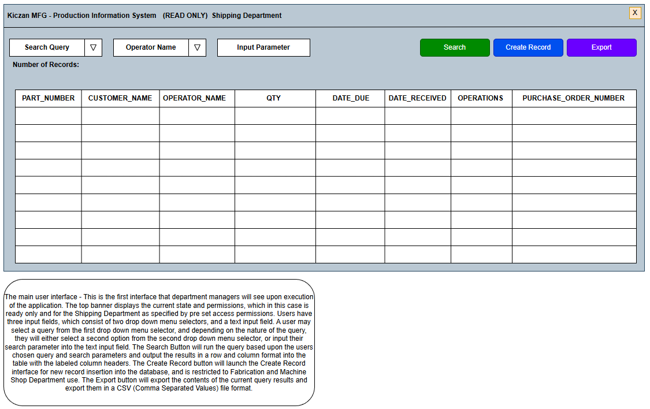

User Story | ERD
1, 2, 3, 4, 5 | PART_HISTORY:  PART_NUMBER,CUSTOMER_NAME  OPERATOR_NAME, QTY, DATE_DUE  DATE_RECEIVED, OPERATIONS  PURCHASE_ORDER_NUMBER

Main User Interface Wireframe – Search by Part Number – Query Success but No Records Found State

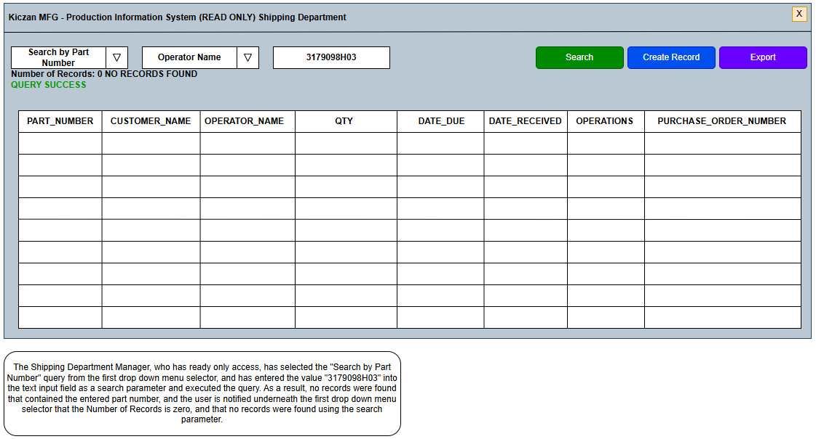

User Story | ERD
1 | CUSTOMERS:  CUSTOMER_ID, CUSTOMER_NAME  OPERATORS:  OPERATOR_ID, OPERATOR_NAME  JOBS:  JOB_ID  PART_HISTORY:  PART_NUMBER,CUSTOMER_NAME  OPERATOR_NAME, QTY, DATE_DUE  DATE_RECEIVED, OPERATIONS  PURCHASE_ORDER_NUMBER

Main User Interface Wireframe – Search by Part Number – Query Failure with Validation Error State

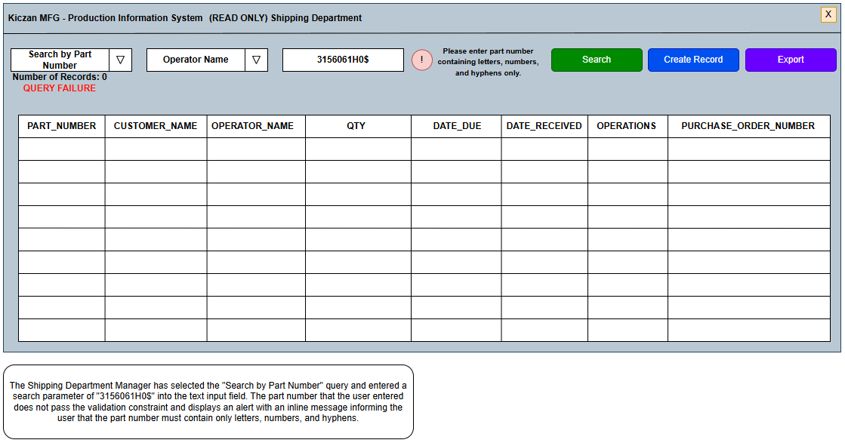

User Story | ERD
1, 6 | CUSTOMERS:  CUSTOMER_ID, CUSTOMER_NAME  OPERATORS:  OPERATOR_ID, OPERATOR_NAME  JOBS:  JOB_ID  PART_HISTORY:  PART_NUMBER,CUSTOMER_NAME  OPERATOR_NAME, QTY, DATE_DUE  DATE_RECEIVED, OPERATIONS  PURCHASE_ORDER_NUMBER

Main User Interface Wireframe – Search by Part Number – Query Success State

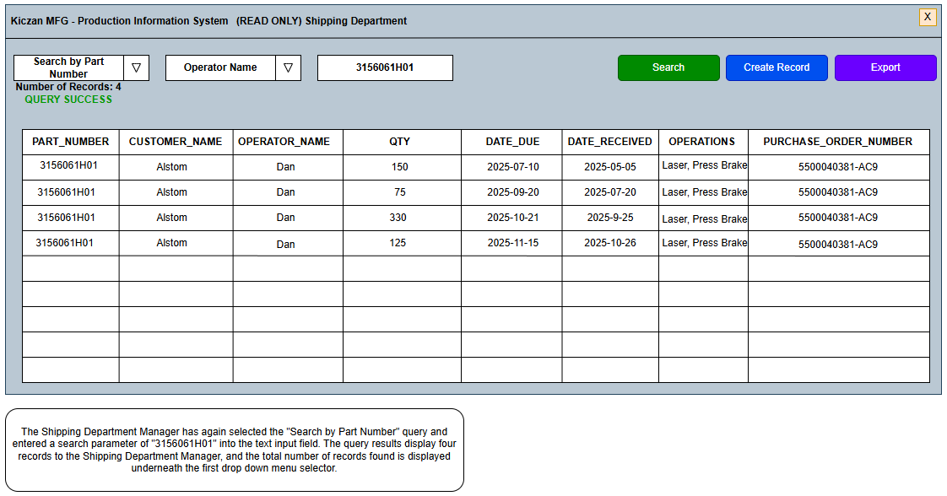

User Story | ERD
1 | CUSTOMERS:  CUSTOMER_ID, CUSTOMER_NAME  OPERATORS:  OPERATOR_ID, OPERATOR_NAME  JOBS:  JOB_ID  PART_HISTORY:  PART_NUMBER,CUSTOMER_NAME  OPERATOR_NAME, QTY, DATE_DUE  DATE_RECEIVED, OPERATIONS  PURCHASE_ORDER_NUMBER

Main User Interface Wireframe – Search by Due Date Range – Query Failure with Validation Error State

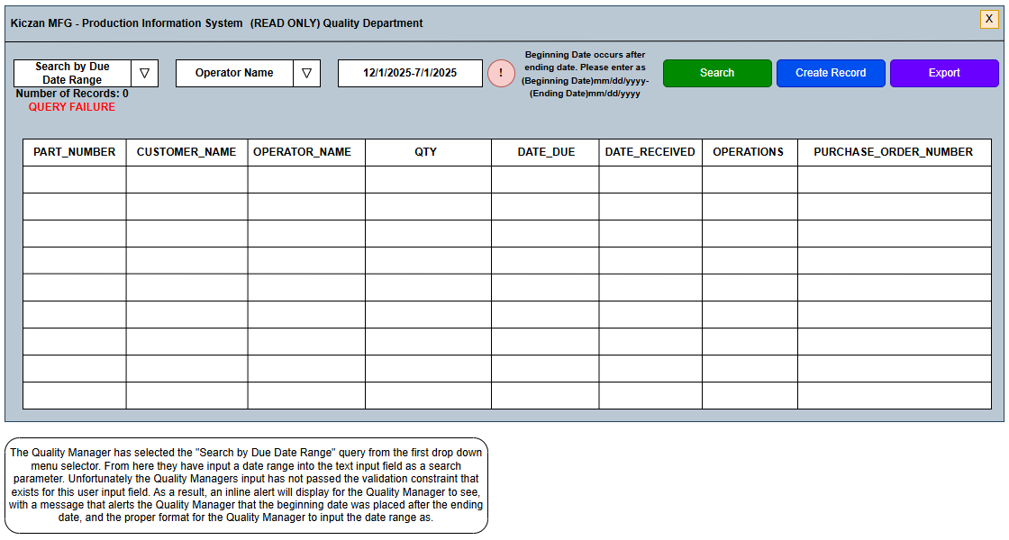

User Story | ERD
2, 6 | CUSTOMERS:  CUSTOMER_ID, CUSTOMER_NAME  OPERATORS:  OPERATOR_ID, OPERATOR_NAME  JOBS:  JOB_ID  PART_HISTORY:  PART_NUMBER,CUSTOMER_NAME  OPERATOR_NAME, QTY, DATE_DUE  DATE_RECEIVED, OPERATIONS  PURCHASE_ORDER_NUMBER

Main User Interface Wireframe – Search by Due Date Range – Query Failure with Validation Error State

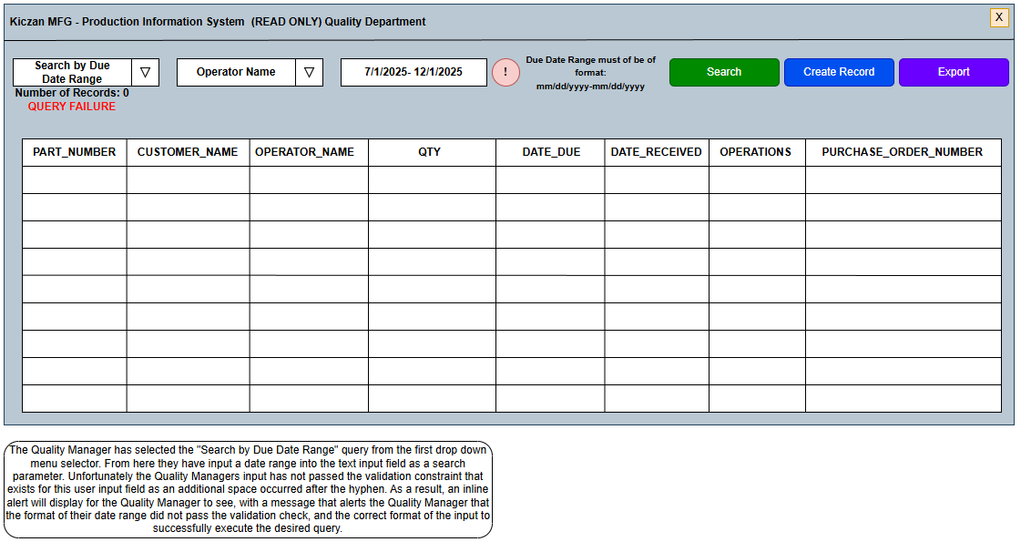

User Story | ERD
2, 6 | CUSTOMERS:  CUSTOMER_ID, CUSTOMER_NAME  OPERATORS:  OPERATOR_ID, OPERATOR_NAME  JOBS:  JOB_ID  PART_HISTORY:  PART_NUMBER,CUSTOMER_NAME  OPERATOR_NAME, QTY, DATE_DUE  DATE_RECEIVED, OPERATIONS  PURCHASE_ORDER_NUMBER

Main User Interface Wireframe – Search by Due Date Range – Query Success State

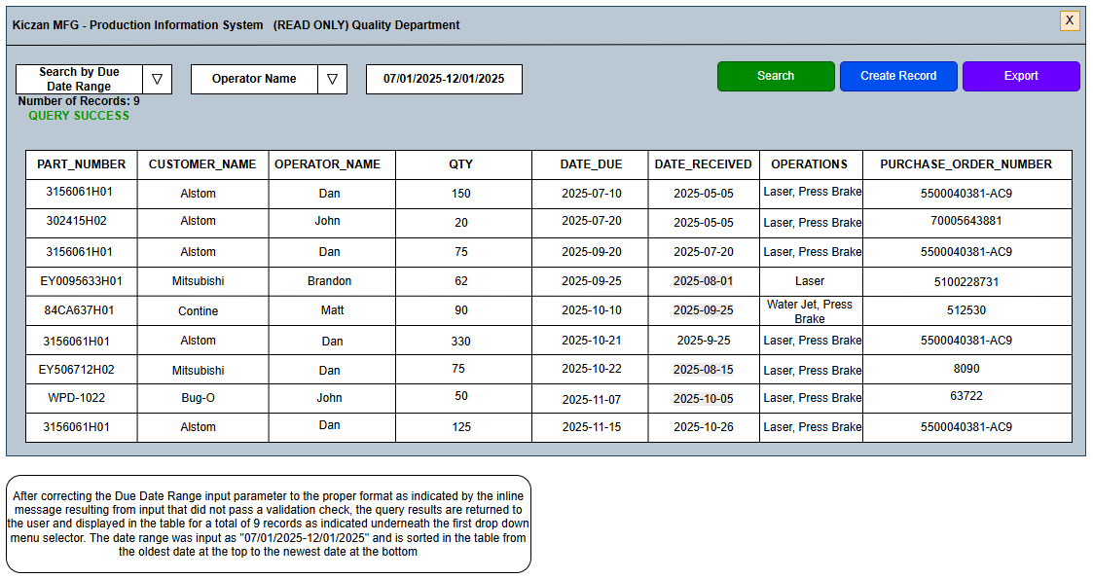

User Story | ERD
2 | CUSTOMERS:  CUSTOMER_ID, CUSTOMER_NAME  OPERATORS:  OPERATOR_ID, OPERATOR_NAME  JOBS:  JOB_ID  PART_HISTORY:  PART_NUMBER,CUSTOMER_NAME  OPERATOR_NAME, QTY, DATE_DUE  DATE_RECEIVED, OPERATIONS  PURCHASE_ORDER_NUMBER

Main User Interface Wireframe – Search by Fabrication Department – Query Success State

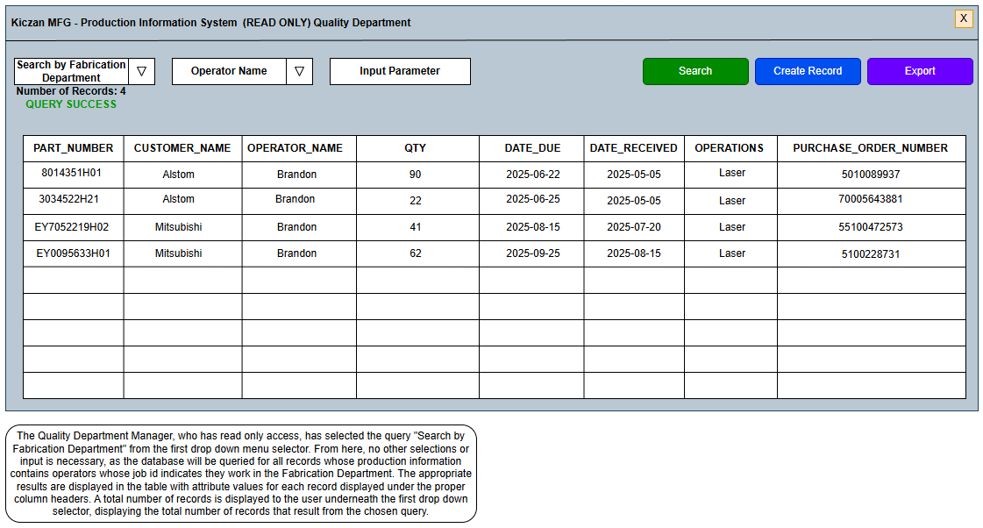

User Story | ERD
4 | CUSTOMERS:  CUSTOMER_ID, CUSTOMER_NAME  OPERATORS:  OPERATOR_ID, OPERATOR_NAME  JOBS:  JOB_ID  PART_HISTORY:  PART_NUMBER,CUSTOMER_NAME  OPERATOR_NAME, QTY, DATE_DUE  DATE_RECEIVED, OPERATIONS  PURCHASE_ORDER_NUMBER

Main User Interface Wireframe – Search by Fabrication Department – Query Success with Paged Results State

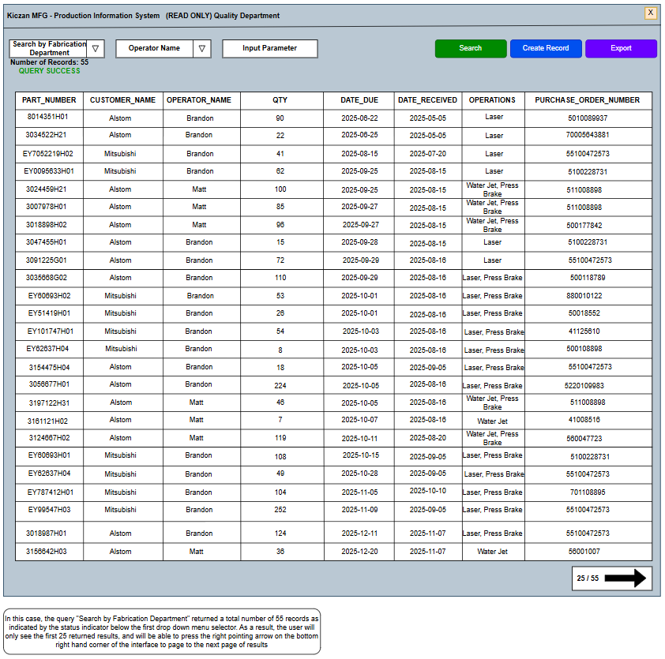

User Story | ERD
4, 7 | CUSTOMERS:  CUSTOMER_ID, CUSTOMER_NAME  OPERATORS:  OPERATOR_ID, OPERATOR_NAME  JOBS:  JOB_ID  PART_HISTORY:  PART_NUMBER,CUSTOMER_NAME  OPERATOR_NAME, QTY, DATE_DUE  DATE_RECEIVED, OPERATIONS  PURCHASE_ORDER_NUMBER
Main User Interface Wireframe – Search by Operator Name – Query Success State

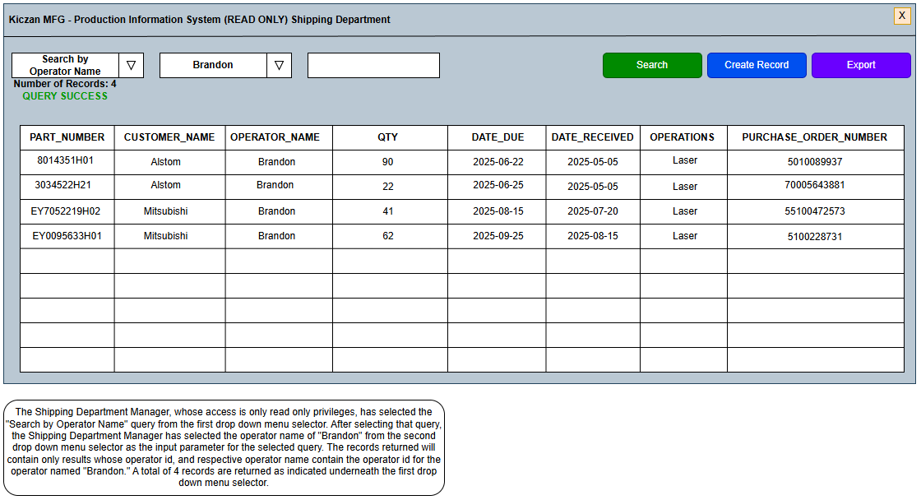

User Story | ERD
3 | CUSTOMERS:  CUSTOMER_ID, CUSTOMER_NAME  OPERATORS:  OPERATOR_ID, OPERATOR_NAME  JOBS:  JOB_ID  PART_HISTORY:  PART_NUMBER,CUSTOMER_NAME  OPERATOR_NAME, QTY, DATE_DUE  DATE_RECEIVED, OPERATIONS  PURCHASE_ORDER_NUMBER

Main User Interface Wireframe – Search by Part Number – Query Success with Delete Record Selection State

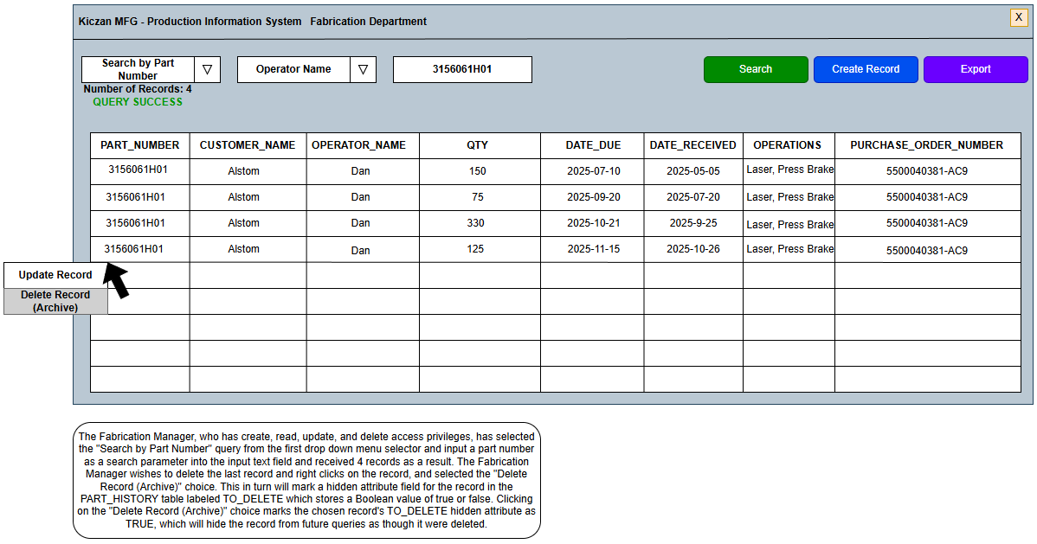

User Story | ERD
5 | PART_HISTORY:  PART_NUMBER  CUSTOMER_NAME  OPERATOR_NAME  QTY  DATE_DUE  DATE_RECEIVED  OPERATIONS  PURCHASE_ORDER_NUMBER  TO_DELETE

Main User Interface Wireframe – Search by Part Number – Query Success with Update Record Selection State

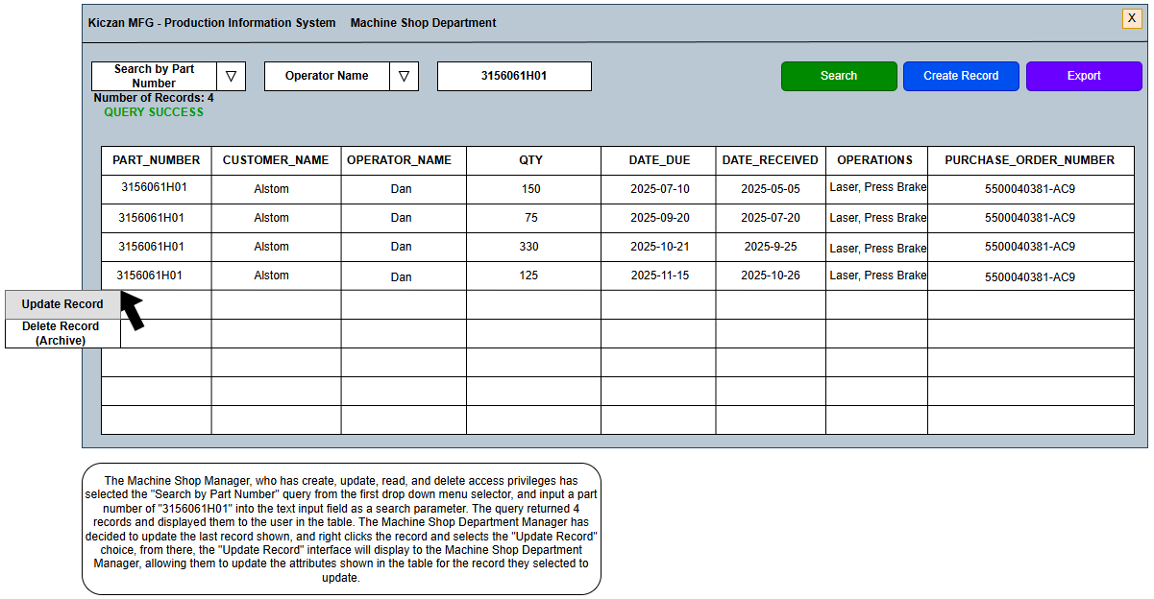

User Story | ERD
5 | PART_HISTORY:  PART_NUMBER  CUSTOMER_NAME  OPERATOR_NAME  QTY  DATE_DUE  DATE_RECEIVED  OPERATIONS  PURCHASE_ORDER_NUMBER

Main User Interface Wireframe – Search by Part Number in Archive – Query Success with Restore Record Selection State

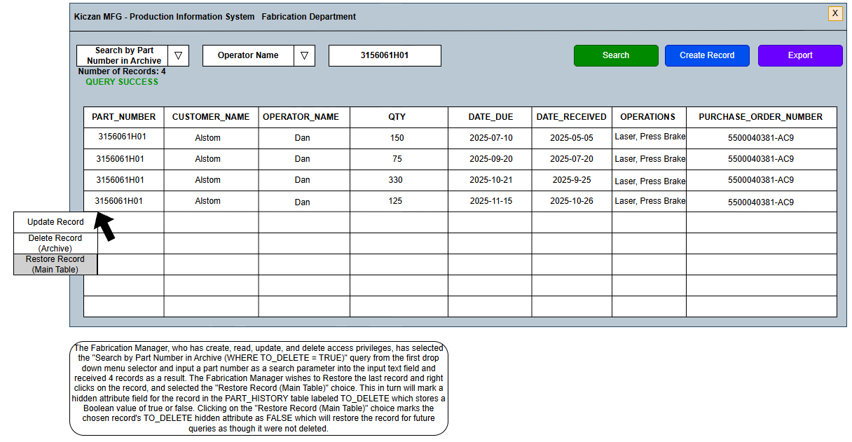

User Story | ERD
5 | PART_HISTORY:  PART_NUMBER  CUSTOMER_NAME  OPERATOR_NAME  QTY  DATE_DUE  DATE_RECEIVED  OPERATIONS  PURCHASE_ORDER_NUMBER  TO_DELETE

Create Record Interface Wireframe – Initial Empty State

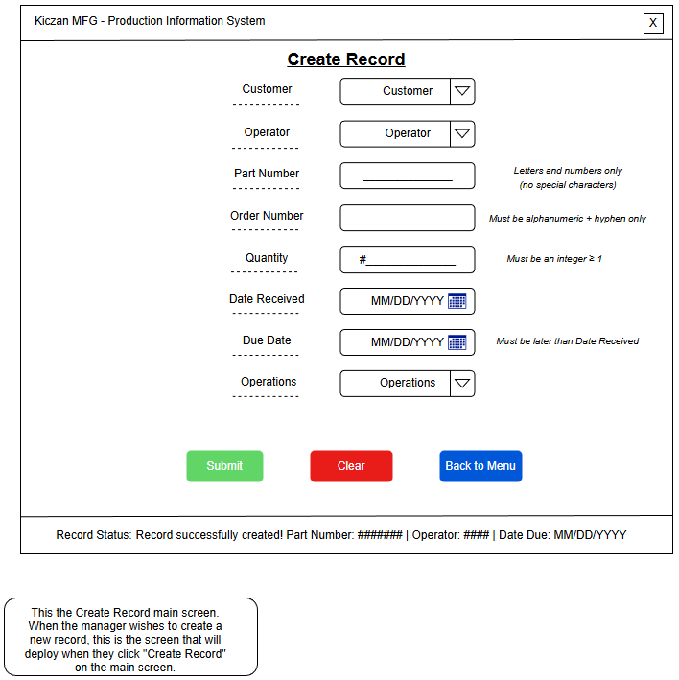
User Story | ERD
5, 6 | PART_HISTORY:  CUSTOMER_ID  OPERATOR_ID  PART_NUMBER  PURCHASE_ORDER_NUMBER  QTY  DATE_RECEIVED  DATE_DUE  OPERATIONS
Create Record Interface Wireframe – Part Number Error Validation State

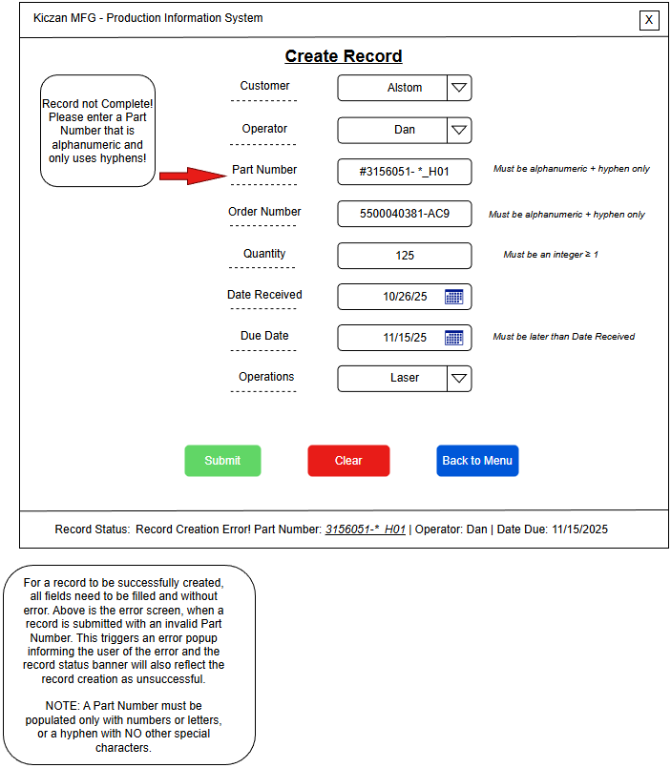
User Story | ERD
5, 6 | PART_HISTORY:  CUSTOMER_ID  OPERATOR_ID  PART_NUMBER  PURCHASE_ORDER_NUMBER  QTY  DATE_RECEIVED  DATE_DUE  OPERATIONS
Create Record Interface Wireframe – Quantity Error Validation State

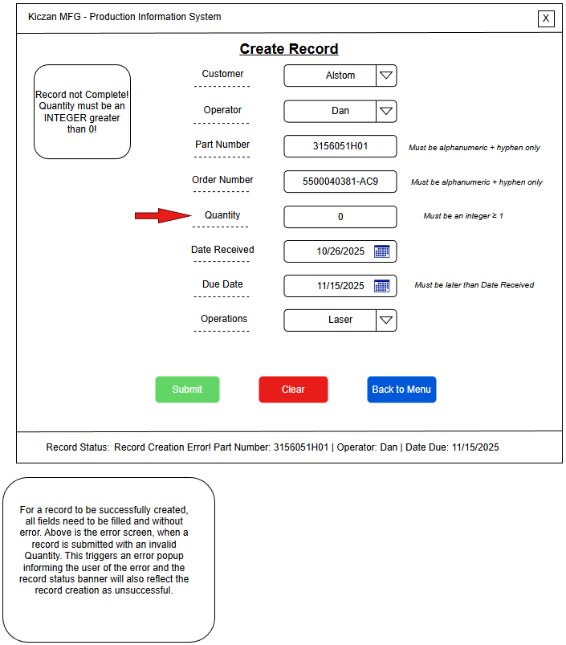
User Story | ERD
5, 6 | PART_HISTORY:  CUSTOMER_ID  OPERATOR_ID  PART_NUMBER  PURCHASE_ORDER_NUMBER  QTY  DATE_RECEIVED  DATE_DUE  OPERATIONS
Create Record Interface Wireframe – Purchase Order Number Error Validation State

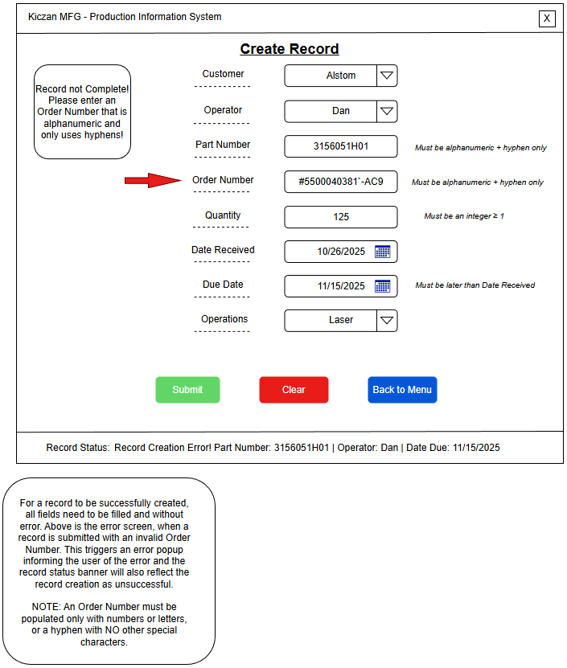
User Story | ERD
5, 6 | PART_HISTORY:  CUSTOMER_ID  OPERATOR_ID  PART_NUMBER  PURCHASE_ORDER_NUMBER  QTY  DATE_RECEIVED  DATE_DUE  OPERATIONS
Create Record Interface Wireframe – Operations Error Validation State

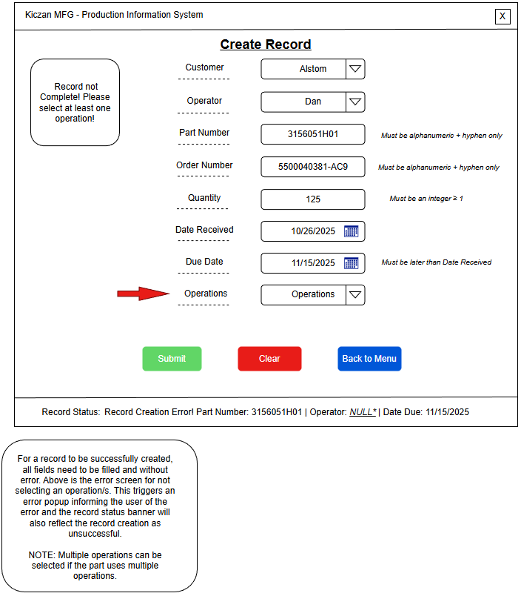
User Story | ERD
5, 6 | PART_HISTORY:  CUSTOMER_ID  OPERATOR_ID  PART_NUMBER  PURCHASE_ORDER_NUMBER  QTY  DATE_RECEIVED  DATE_DUE  OPERATIONS
Create Record Interface Wireframe – Date Format Error Validation State

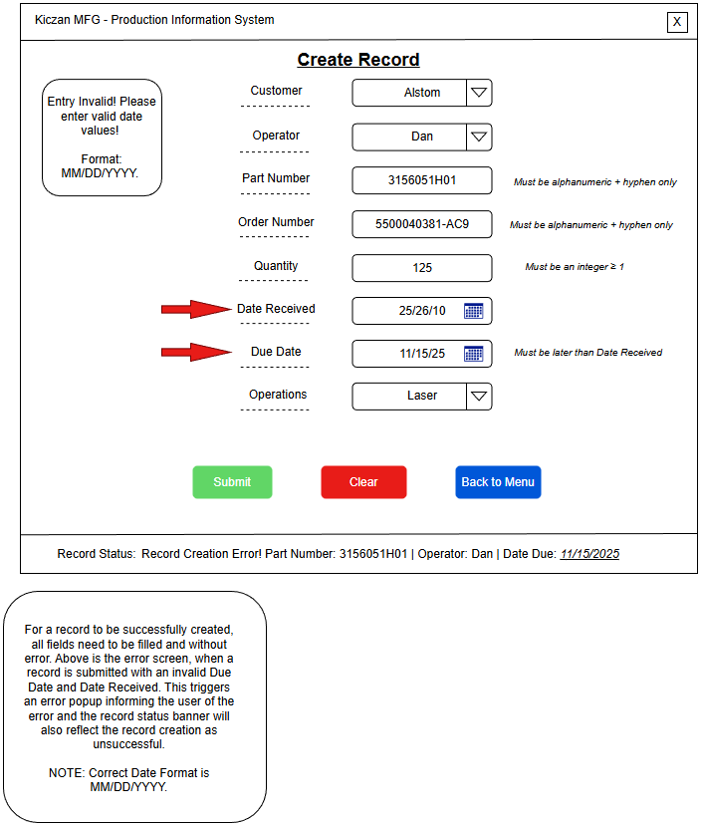
User Story | ERD
5, 6 | PART_HISTORY:  CUSTOMER_ID  OPERATOR_ID  PART_NUMBER  PURCHASE_ORDER_NUMBER  QTY  DATE_RECEIVED  DATE_DUE  OPERATIONS
Create Record Interface Wireframe – Date Due Error Validation State

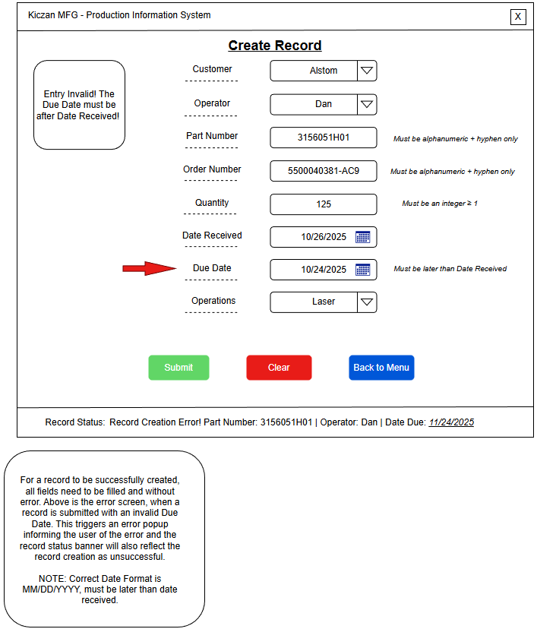

User Story | ERD
5, 6 | PART_HISTORY:  CUSTOMER_ID  OPERATOR_ID  PART_NUMBER  PURCHASE_ORDER_NUMBER  QTY  DATE_RECEIVED  DATE_DUE  OPERATIONS
Create Record Interface Wireframe – Customer Error Validation State

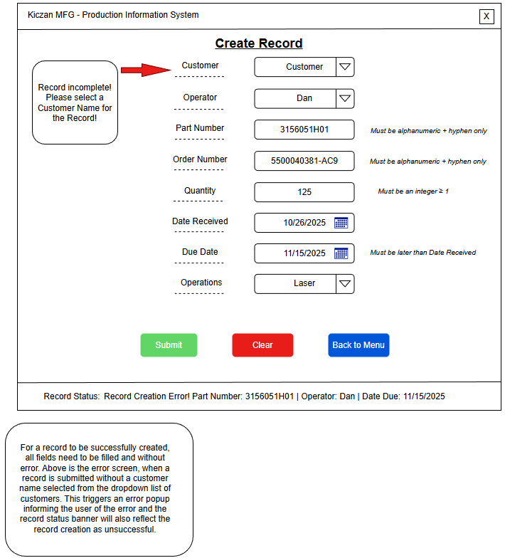
User Story | ERD
5, 6 | PART_HISTORY:  CUSTOMER_ID  OPERATOR_ID  PART_NUMBER  PURCHASE_ORDER_NUMBER  QTY  DATE_RECEIVED  DATE_DUE  OPERATIONS
Create Record Interface Wireframe – Record Insertion Success State

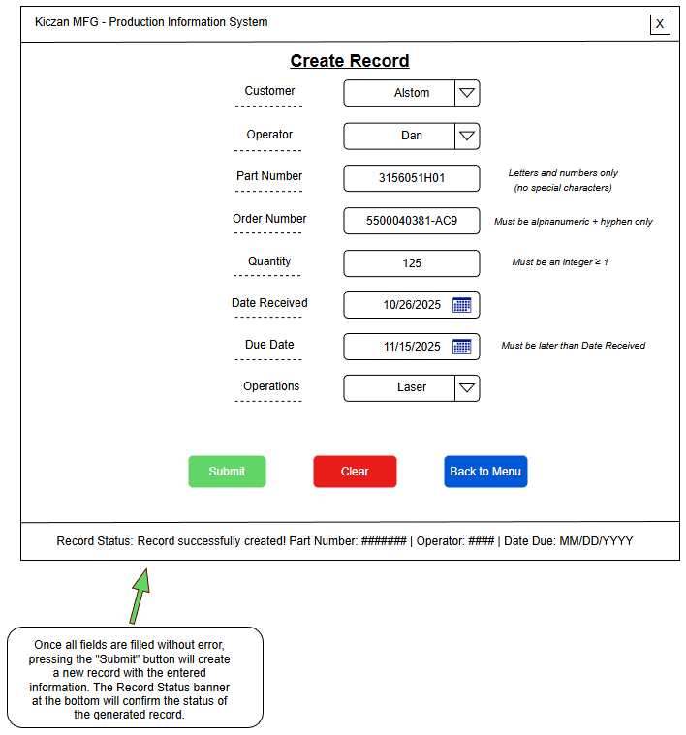
User Story | ERD
5, 6 | PART_HISTORY:  CUSTOMER_ID  OPERATOR_ID  PART_NUMBER  PURCHASE_ORDER_NUMBER  QTY  DATE_RECEIVED  DATE_DUE  OPERATIONS
Create Record Interface Wireframe – Clear and Menu Button State

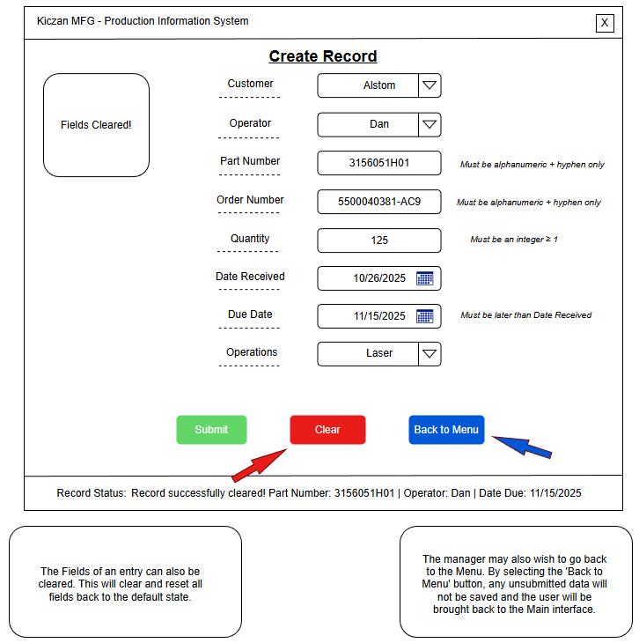
User Story | ERD
5, 6 | PART_HISTORY:  CUSTOMER_ID  OPERATOR_ID  PART_NUMBER  PURCHASE_ORDER_NUMBER  QTY  DATE_RECEIVED  DATE_DUE  OPERATIONS
Update Record Wireframe – Initial Empty State
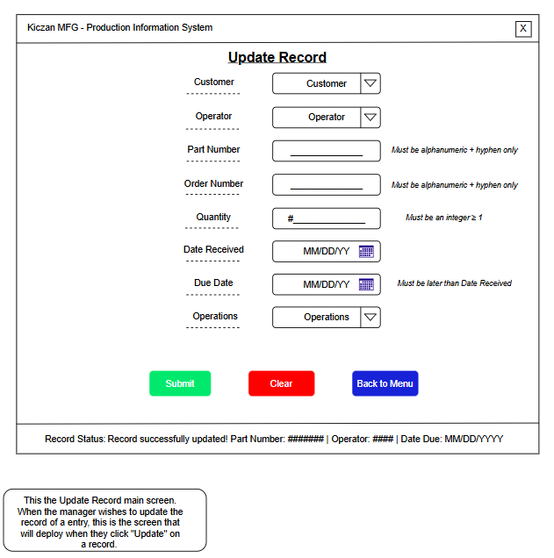
User Story | ERD
5, 6 | PART_HISTORY:  CUSTOMER_ID  OPERATOR_ID  PART_NUMBER  PURCHASE_ORDER_NUMBER  QTY  DATE_RECEIVED  DATE_DUE  OPERATIONS

Update Record Wireframe – Example Record, with Record Selected
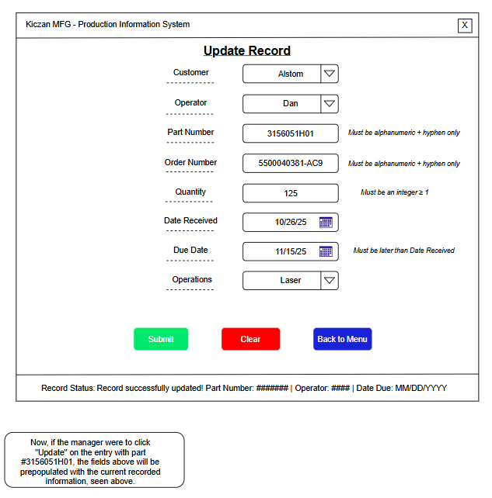
User Story | ERD
5, 6 | PART_HISTORY:  CUSTOMER_ID  OPERATOR_ID  PART_NUMBER  PURCHASE_ORDER_NUMBER  QTY  DATE_RECEIVED  DATE_DUE  OPERATIONS

Update Record Wireframe – Missing Customer Entry Error

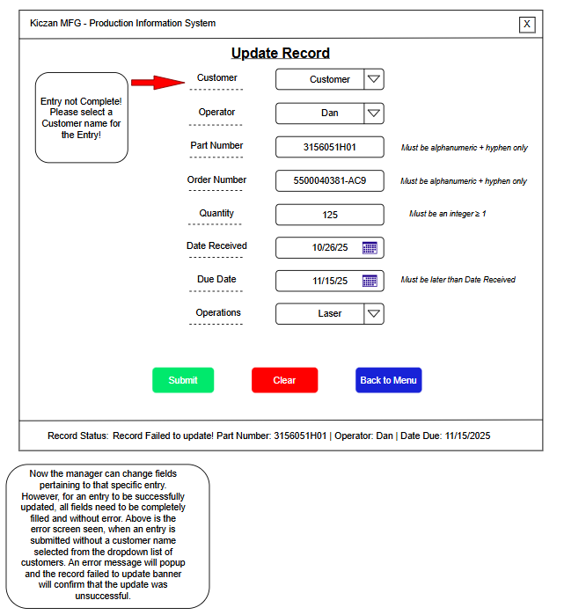
User Story | ERD
5,6 | PART_HISTORY:  CUSTOMER_ID, OPERATOR_ID  PART_NUMBER, PURCHASE_ORDER_NUMBER  QTY, DATE_RECEIVED, DATE_DUE  OPERATIONS
Update Record Wireframe – Missing Operator Entry Error

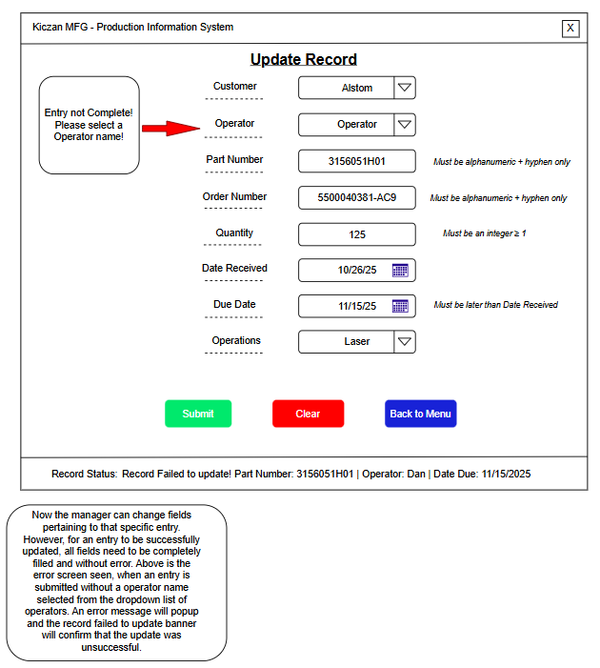
User Story | ERD
5,6 | PART_HISTORY:  CUSTOMER_ID, OPERATOR_ID  PART_NUMBER, PURCHASE_ORDER_NUMBER  QTY, DATE_RECEIVED, DATE_DUE  OPERATIONS
Update Record Wireframe – Missing Operations Entry Error

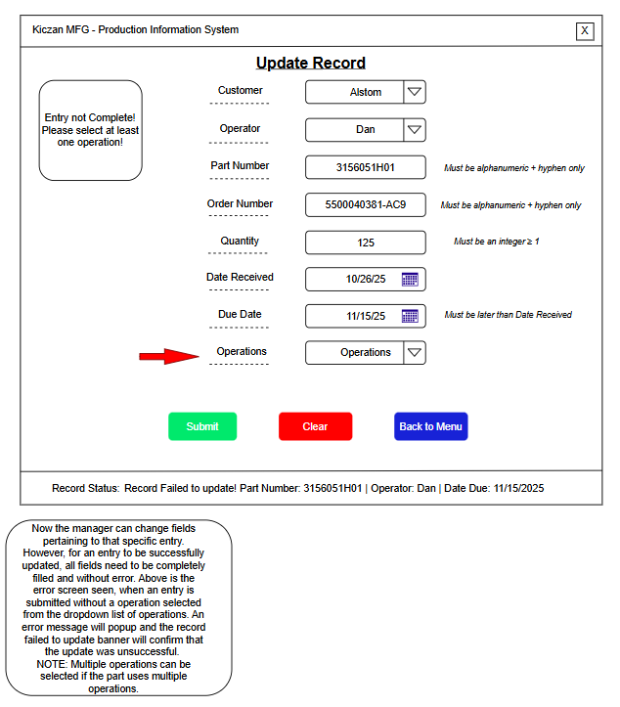
User Story | ERD
5,6 | PART_HISTORY:  CUSTOMER_ID, OPERATOR_ID  PART_NUMBER, PURCHASE_ORDER_NUMBER  QTY, DATE_RECEIVED, DATE_DUE  OPERATIONS
Update Record Wireframe – Quantity Entry Error

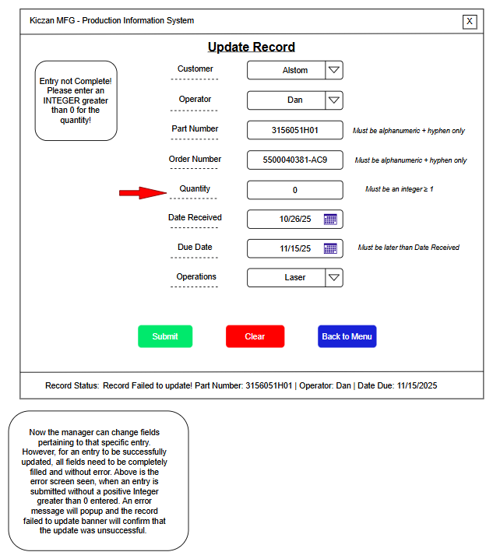
User Story | ERD
5,6 | PART_HISTORY:  CUSTOMER_ID, OPERATOR_ID  PART_NUMBER, PURCHASE_ORDER_NUMBER  QTY, DATE_RECEIVED, DATE_DUE  OPERATIONS
Update Record Wireframe – Part Number Entry Error

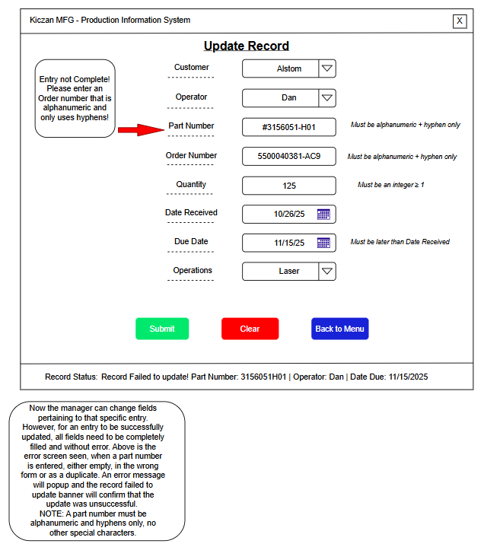
User Story | ERD
5,6 | PART_HISTORY:  CUSTOMER_ID, OPERATOR_ID  PART_NUMBER, PURCHASE_ORDER_NUMBER  QTY, DATE_RECEIVED, DATE_DUE  OPERATIONS
Update Record Wireframe – Order Number Entry Error

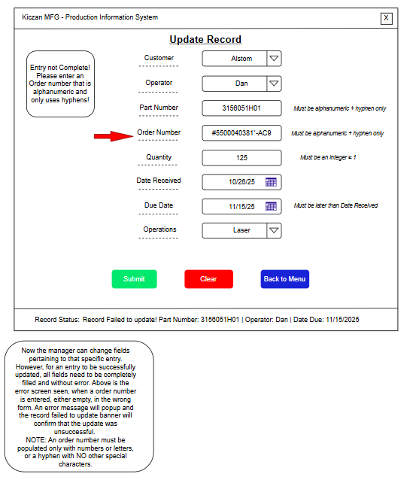
User Story | ERD
5,6 | PART_HISTORY:  CUSTOMER_ID, OPERATOR_ID  PART_NUMBER, PURCHASE_ORDER_NUMBER  QTY, DATE_RECEIVED, DATE_DUE  OPERATIONS

Update Record Wireframe – Received and Due Date Entry Error

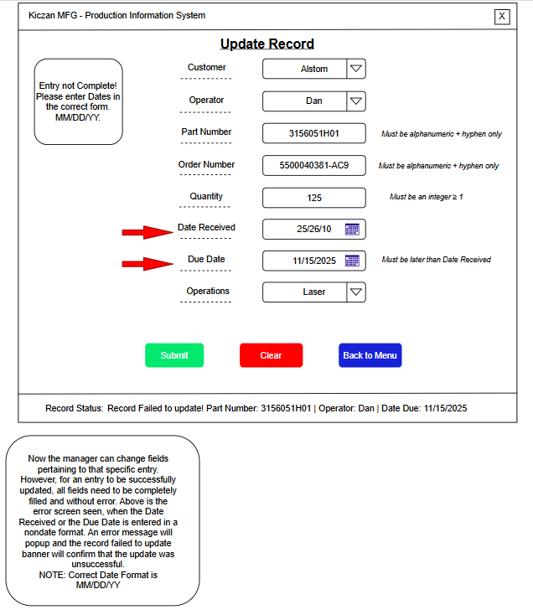
User Story | ERD
5,6 | PART_HISTORY:  CUSTOMER_ID, OPERATOR_ID  PART_NUMBER, PURCHASE_ORDER_NUMBER  QTY, DATE_RECEIVED, DATE_DUE  OPERATIONS
Update Record Wireframe – Due Date Entry(Earlier than Received) Error

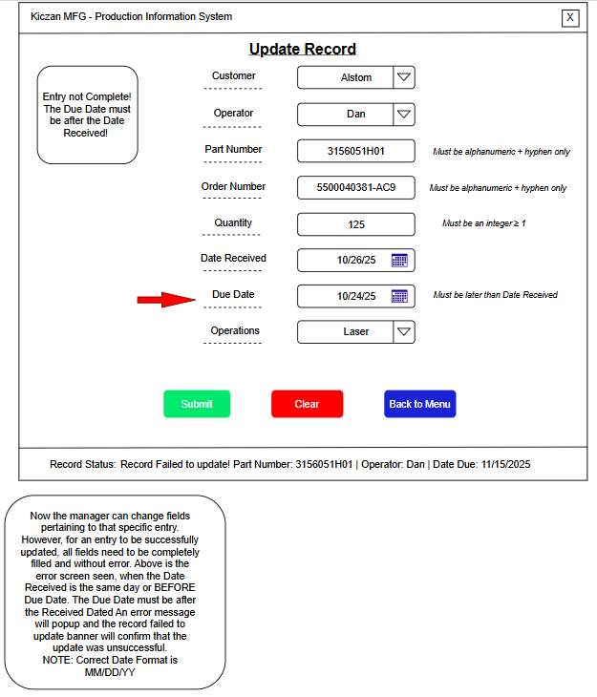
User Story | ERD
5,6 | PART_HISTORY:  CUSTOMER_ID, OPERATOR_ID  PART_NUMBER, PURCHASE_ORDER_NUMBER  QTY, DATE_RECEIVED, DATE_DUE  OPERATIONS
Update Record Wireframe – Successful Entry State

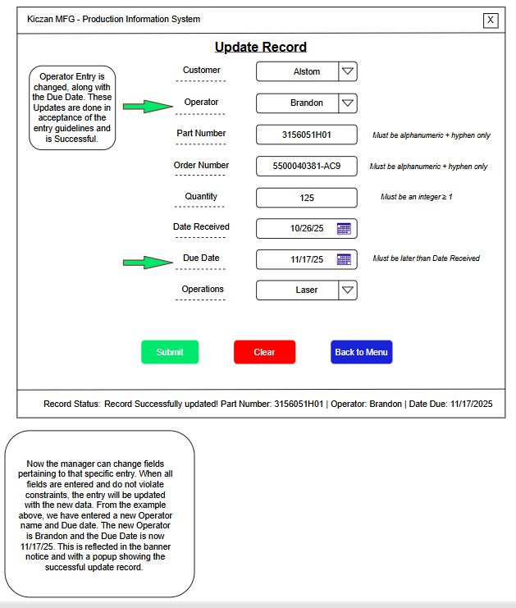

User Story | ERD
5,6 | PART_HISTORY:  CUSTOMER_ID, OPERATOR_ID  PART_NUMBER, PURCHASE_ORDER_NUMBER  QTY, DATE_RECEIVED, DATE_DUE  OPERATIONS
Update Record Wireframe – Using the “Clear” and “Back to Menu” Buttons

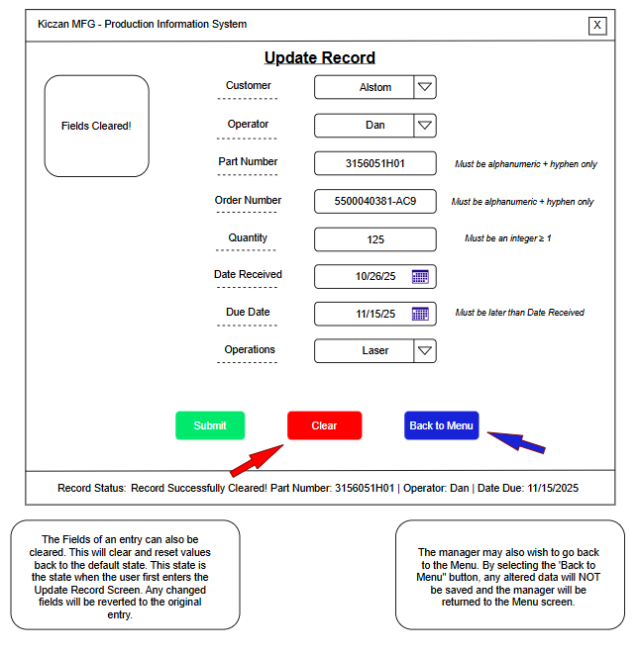
User Story | ERD
5,6 | PART_HISTORY:  CUSTOMER_ID, OPERATOR_ID  PART_NUMBER, PURCHASE_ORDER_NUMBER  QTY, DATE_RECEIVED, DATE_DUE  OPERATIONS

